HONG KONG INSTITUTE OF VOCATIONAL EDUCATION
Laboratory 5a: Abstract Class

TASK:
1. Write the supplier classes in the following parts below:
Shape

__name : str

__init__ (self, name = “Shape”)
find_area (self) : float
find_perimeter (self) : float
display (self, end = “”)
get_number_of_shapes()

Circle

__radius : float
__number_of_circle

__init__ (self, radius, name = “Circle”)
find_area (self)
find_perimeter (self)
get_number_of_shapes() : int
display (self, end = “”)

Rectangle

__length : float
__width : float
__number_of_rectangle : int

__init__ (self, length, width,
name = “Rectangle”)
find_area (self) : float
find_perimeter (self) : float
get_number_of_shapes() : int
display (self, end = “”)

Cylinder

__length : float
__number_of_cylinder

__init__ (self, radius, length,
name = “Cylinder”)
find_area (self)
find_perimeter (self)
find_volume (self)
get_number_of_shapes() : int
display (self, end = “”)

RightAngledTriangle

__base_length : float
__height : float
__number_of_triangle : int

__init__ (self, base_length, height,
name = “Right-angled Triangle”)
find_area (self)
find_perimeter (self)
get_number_of_shapes() : int
display (self, end = “”)

(a) Create an abstract class Shape that has:
Attributes:
__name – to store the name of the shape
Methods:
__init__ – initialize the name attribute with default value “Shape” in shape object.
find_area – an abstract method used to force all child class implement this method. Since the area of shape cannot be calculated without more details given
find_perimeter – an abstract method used to force all child class implement this method. Since the perimeter of shape cannot be calculated without more details given
get_number_of_shapes – an abstract static method used to force all child class implement this method. All child class should use static method to return the total number of corresponding shapes created
display – to print the output with the sample given

(b) Create a class Circle inherit from class Shape that has:
Attributes:
__number_of_circle – a static variable to store the total number of circles created. Assign this variable to 0 at class level
__radius – to store the radius of the circle
Methods:
__init__ – initialize the radius attribute and name attribute with default value “Circle” in circle object. Super method call is used to call parent class __init__ method to initialize the name attribute. Add 1 to number of circle when a circle object is created
find_area – override the parent class find_area abstract method to return the area of circle calculated
find_perimeter – override the parent class find_perimeter abstract method to return the perimeter of circle calculated
get_number_of_shapes – override the parent class get_number_of_shapes abstract static method to return the static variable total number of circles
display – override the parent class display method to print the output with the sample given. Super method call is used to call parent class display method to display the name of circle

(c) Create a class Rectangle inherit from class Shape that has:
Attributes:
__number_of_rectangle – a static variable to store the total number of rectangles created. Assign this variable to 0 at class level
__length – to store the length of the rectangle
__width – to store the width of the rectangle
Methods:
__init__ – initialize the length attribute, width attribute and name attribute with default value “Rectangle” in rectangle object. Super method call is used to call parent class __init__ method to initialize the name attribute. Add 1 to number of rectangle when a rectangle object is created
find_area – override the parent class find_area abstract method to return the area of rectangle calculated
find_perimeter – override the parent class find_perimeter abstract method to return the perimeter of rectangle calculated
get_number_of_shapes – override the parent class get_number_of_shapes abstract static method to return the static variable total number of rectangles
display – override the parent class display method to print the output with the sample given. Super method call is used to call parent class display method to display the name of rectangle
(d) Create a class RightAngledTriangle inherit from class Shape that has:
Attributes:
__number_of_triangle – a static variable to store the total number of right-angled triangles created. Assign this variable to 0 at class level
__base_length – to store the base_length of the right-angled triangle
__height – to store the height of the right-angled triangle
Methods:
__init__ – initialize the base_length attribute, height attribute and name attribute with default value “Right-angled Triangle” in right-angled triangle object. Super method call is used to call parent class __init__ method to initialize the name attribute. Add 1 to number of triangle when a right-angled triangle object is created
find_area – override the parent class find_area abstract method to return the area of right-angled triangle calculated
find_perimeter – override the parent class find_perimeter abstract method to return the perimeter of right-angled triangle calculated
get_number_of_shapes – override the parent class get_number_of_shapes abstract static method to return the static variable total number of right-angled triangle
display – override the parent class display method to print the output with the sample given. Super method call is used to call parent class display method to display the name of right-angled triangle
(e) Create a class Cylinder inherit from class Circle that has:
Attributes:
__number_of_cylinder – a static variable to store the total number of cylinders created. Assign this variable to 0 at class level
__length – to store the length of the cylinder
Methods:
__init__ – initialize the radius attribute length attribute and name attribute with default value “Cylinder” in cylinder object. Super method call is used to call parent class __init__ method to initialize the radius and name attributes. Add 1 to number of cylinder when a cylinder object is created
find_area – override the parent class find_area abstract method to return the total surface area of cylinder calculated
find_perimeter – override the parent class find_perimeter abstract method to return the surface of side (perimeter of circle * length) of cylinder calculated
find_volume - return the volume of cylinder calculated
get_number_of_shapes – override the parent class get_number_of_shapes abstract static method to return the static variable total number of cylinders
display – override the parent class display method to print the output with the sample given. Super method call is used to call parent class display method to display the area, perimeter and name of cylinder

Client / Driver program of the above class are given below. You are NOT allowed to modify the client / driver program:

from abc import ABC, abstractmethod
class Shape(ABC):
@staticmethod
@abstractmethod
def get_number_of_shapes():
return NotImplemented
...

#You are NOT allowed to modify following codes
if __name__=="__main__":
list_shape = list()
#Shape objects can no longer be created anymore
#list_shape.append(Shape())
#list_shape.append(Shape("Pentagon"))
list_shape.append(Circle(1))
list_shape.append(Rectangle(2,2))
list_shape.append(RightAngledTriangle(3,4))
list_shape.append(Cylinder(1,3))
for shape in list_shape:
shape.display()
print (f"There are {Circle.get_number_of_shapes()}"
f" circle(s) in total")
print (f"There are {Rectangle.get_number_of_shapes()}"
f" rectangle(s) in total")
print (f"There are {RightAngledTriangle.get_number_of_shapes()}"
f" right-angled triangle(s) in total")
print (f"There are {Cylinder.get_number_of_shapes()}"
f" cylinder(s) in total")

Output:
This is a Circle with area = 3.14, perimeter = 6.28
This is a Rectangle with area = 4.00, perimeter = 8.00
This is a Right-angled Triangle with area = 6.00, perimeter = 12.00
This is a Cylinder with area = 25.13, perimeter = 18.85, volume = 9.42
There are 2 circle(s) in total
There are 1 rectangle(s) in total
There are 1 right-angled triangle(s) in total
There are 1 cylinder(s) in total

Answer:

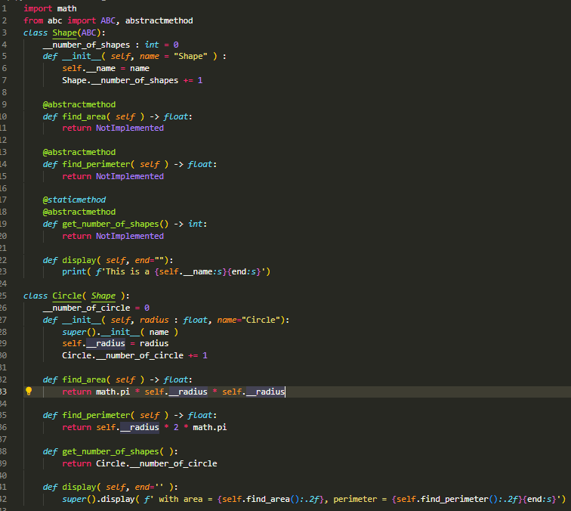
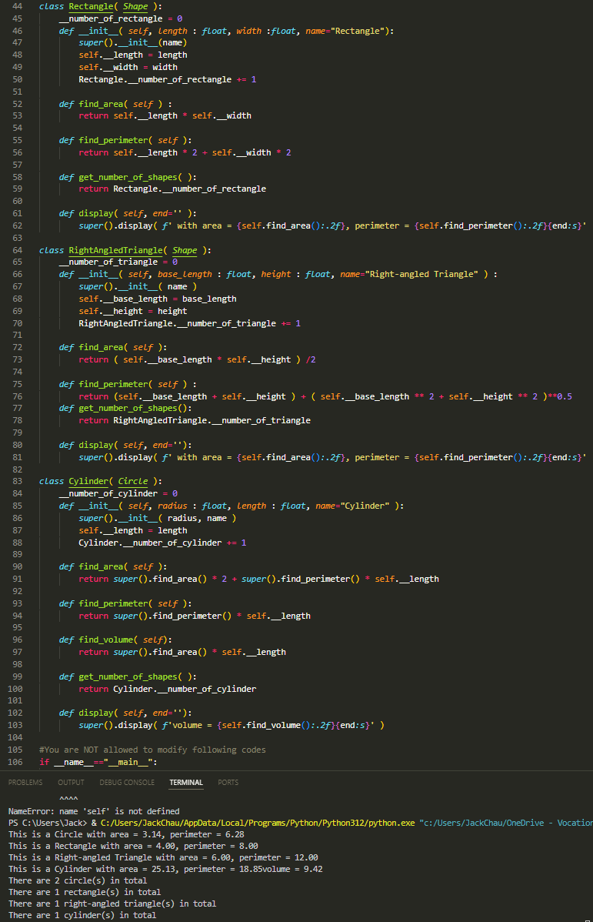
2. You are given the following supplier classes:

#No need to modify the student class
class Student :
def __init__(self, id, name):
self.__id = id
self.__name = name
self.__list_module = list()
def add_module(self, module):
self.__list_module.append(module)
def get_list_module(self):
return self.__list_module
def display(self):
print (f"Student {self.__name} ({self.__id}) "
f"enrolled the following module(s):")
for module in self.__list_module:
print (module)

class Module:
def __init__(self, id, name):
self.__id = id
self.__name = name
#implement your methods here

The following client / driver program is given for you to test your classes:

#You are not allowed to modify the following program
if __name__ == "__main__":
list_student = list()
kelvin = Student("201234567","Kelvin")
kelvin.add_module(Module("ITE3102", "Network Fundamentals"))
kelvin.add_module(Module("ITP3915",
"Programming Fundamentals"))
kelvin.add_module(Module("ITP4456", "Database Applications"))
kelvin.add_module(Module("ITP4451", "IoT Fundamentals"))
kelvin.add_module(Module("ITP4457", "Web Technologies"))
kelvin.add_module(Module("ITP4458", "Wireless Technologies"))
kelvin.add_module(Module("ITP4459",
"Advanced Scripting Technology"))

peter = Student("202345678", "Peter")
peter.add_module(Module("ITE3102", "Network Fundamentals"))
peter.add_module(Module("ITP3915",
"Programming Fundamentals"))
peter.add_module(Module("ITP4456", "Database Applications"))
peter.add_module(Module("ITP4459",
"Advanced Scripting Technology"))
peter.add_module(Module("ITP4410", "Internet Programming"))
peter.add_module(Module("ITP4413", "Server Administration"))

list_student.append(kelvin)
list_student.append(peter)

# display stduent information
for student in list_student:
student.display()

# display student common modules
print ("Both Kelvin and Peter studies in the following modules:")
for module1 in kelvin.get_list_module():
for module2 in peter.get_list_module():
if module1 == module2:
print (module1)

Add a __str__() method in Module class return a string related to modules as shown in the sample output below. Add a __eq__() method in Module class to allow comparisons between two module by their module id. The two module are treated as equal if they have the same module id.
Output:
Student Kelvin (201234567) enrolled the following module(s):
ITE3102 - Network Fundamentals
ITP3915 - Programming Fundamentals
ITP4456 - Database Applications
ITP4451 - IoT Fundamentals
ITP4457 - Web Technologies
ITP4458 - Wireless Technologies
ITP4459 - Advanced Scripting Technology
Student Peter (202345678)enrolled the following module(s):
ITE3102 - Network Fundamentals
ITP3915 - Programming Fundamentals
ITP4456 - Database Applications
ITP4459 - Advanced Scripting Technology
ITP4410 - Internet Programming
ITP4413 - Server Administration
Both Kelvin and Peter studies in the following modules:
ITE3102 - Network Fundamentals
ITP3915 - Programming Fundamentals
ITP4456 - Database Applications
ITP4459 - Advanced Scripting Technology
Answers:

